## AIM-**Design a system for car stereo systems such that whenever the increase volume button is pressed, a Green Light is emitted for 20 ms & whenever the decrease volume button is pressed, a Red Light is emitted for 40 ms.**

Circuit Diagram:

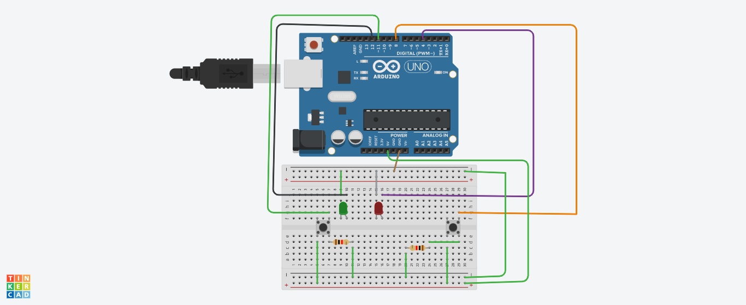

Theory:

**car stereo systems such that whenever the increase volume button is pressed, a Green Light is emitted for 20 ms & whenever the decrease volume button is pressed, a Red Light is emitted for 40 ms.**

**When pushbutton connected to the pinmode11 press which is connected to the volume up then Red light blink for 40 milisecond.**

**When pushbutton connected to the pinmode8 press which is connected to the volume up then green light blink for 20 milisecond.**

Problems & Troubleshooting:

1. Problem in fixing wire from bread board to arduino.
2. Problem in doing arduino programming.

Precautions:

1. Correct conection of negative and positive terminal of led.
2. Don’t put arduino near water.
3. Check the USB port of computer is working .
4. Check the arduino software and select the correct port (in which arduino is connected).

**CODE-**

boolean val= 0;

boolean wal= 0;

void setup()

{

pinMode(4,OUTPUT);

pinMode(8,INPUT);

pinMode(11,INPUT);

pinMode(12,OUTPUT);

}

void loop()

{

val = digitalRead(11);

wal = digitalRead(8);

if(val==HIGH)

{

digitalWrite(4,HIGH);

delay(40);

digitalWrite(4,LOW);

delay(40);

}

else

{

digitalWrite(4,LOW);

}

if(wal==HIGH)

{digitalWrite(12,HIGH);

delay(20);

digitalWrite(12,LOW);

delay(20);

}

else

{

digitalWrite(12,LOW);

}

}